BATTERY MANAGEMENT SYSTEMS FOR ELECTRIC VEHICLE APPLICATIONS
Theory And Concepts
This paper introduces many theoretical concepts which I will explain in this section-
- SOC – State Of Charge, It refers to the amount of charge left in a battery , normally it takes the rated capacity of a new battery cell as 100%.
- SOH- State Of Health: It basically reflects the overall health of a battery how much capacity it has with respect to the original capacity.
- Colomb Counting: Is a method to calculate SOC by basically integrating the current over time to get the charge that has left the batter, it can be reasonably accurate when temperature and discharge rate variations are also taken into account.
- Voltage Delay Method- This method is generally used when the battery is outside the car, a transient load is applied across the battery and its voltage response is calculated to get the SOC of the battery
- Impedance spectroscopy: It is a method that can calculate both SOC and SOH where an applied signal which is small amplitude, ac waveform is given to the battery and its voltage and current responses are observed, however this method is expensive and temperature sensitive.
- Peukert’s Equation- it is a equation which says that , the discharge current of a battery decreases with increasing the discharge time. And gives the following relation
$I^{n}* T = constant$
Here n is a battery constant and T is time to discharge at current .
- Fuzzy Logic Methodology: Instead of using binary this logic allows values between 0 and 1 allowing more possibilities and can be used in uncertain conditions.

PROBLEM ADDRESSED
The problems the BMS addresses is very simple , Batteries are volatile in nature their total capacity changes over the time , we are at times unable to find out the charge left in a battery, this may cause overcharging of the battery, This can cause major problems like Cell imbalance (in case of multiple cell usage), cell overcharging (normal charging or in cases like regenerative braking) or overdischarging . Both of these events are a major cause of battery failure. There is also an issue of overheating where a cell may even burn causing safety hazards.
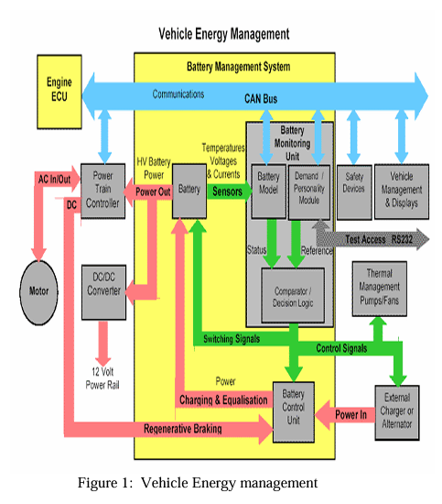
METHOD PROPOSED
The proposed solution is implementation of a BMS system consisting of three units BCU (Battery Control Unit), BMU(Battery Monitoring Unit), CAN BUS .
In the proposed solution BMS uses impedence response at various specific frequencies to find out many different things including SOC using SOC algorithms based on peukerts’s equation .
it also measures the temperature of battery . It also goes about and stores a history of charge and discharge cycles to estimate SOH.
For this two types of memory are proposed one is the ROM(Read only memory ) which stores the information about current, temperature , EMF if the SOC algorithm is based on it, and all of there relations with SOC are stored here.
Second is RAM in which history of charge and discharge cycles are stored.
Finally the BMS uses the fuzzy logic methodology and looks whether the SOC or the temperature are going beyond the acceptable range and if yes it disconnects the DC link and turns on the alarm

